***Am I allowed to use a t-test as a post hoc test to see if one is significantly greater than the other? (don’t think so actually), so probably should just use Tukey instead – but confirm this with Marissa!

## Survival

Diet had a significant effect on survival rate (Diet: χ2= 20.33, df = 3, p < 0.001; Temperature: χ2= 2.01, df = 1, p = 0.16; Treatment χ2= 23.74, df = 7, p < 0.01; Figure 4) within the first nine weeks of the experiment. The kelp dietary treatment had a significantly lower (Dunn – Bonferroni test, p < 0.05) survival rate (%) than all other dietary treatments in this period. Many urchins in the kelp dietary treatment group showed severe spine loss and were removed from the tanks for disease and water quality concerns (Appendix, Figure A1). Due to the consistently poor survival rate during the early stages of the experiment and concerns for the health of the animals, the kelp dietary treatment was suspended. Kelp dietary treatment urchins were ethically euthanized as per DFFE biosecurity regulation and kelp was removed from the mixed dietary treatment feeding regime, changing the mixed diet regime to ulva and formulated feed rotated on a weekly basis from week 10 onwards. Eliminating the kelp dietary treatment increased the significance of the temperature treatment effect on survival rate (Week 10 - Diet: χ2= 3.12, df = 2, p = 0.21; Temperature: χ2= 5.76, df = 1, p < 0.05; Treatment: χ2= 9.78, df = 5, p = 0.08) (Week 18 – Diet: χ2= 1.40, df = 2, p = 0.50; Temperature: χ2= 7.77, df = 1, p < 0.01; Treatment: χ2= 10.07, df = 5, p = 0.07) (Week 24 – Diet: χ2= 1.52, df = 2, p = 0.47; Temperature: χ2= 6.25, df = 1, p < 0.05; Treatment: χ2= 8.58, df = 5, p = 0.13). The warm temperature treatment group had a significantly higher survival rate than the ambient temperature treatment group overall ((Dunn – Bonferroni test, p <0.05). (Sig differences over time between week 10 and 24?)

*Kelp dietary treatment*

Cape sea urchin survival rates differed significantly between treatments after 8 weeks (χ2= 18.16, df = 7, p-value < 0.05). Many urchins in the kelp (k) dietary treatment group showed severe spine loss and were removed from the tanks due to poor health and water quality concerns (Figure 1*). As a result of this, the kelp dietary treatment tanks had the lowest survival rates with (mean ± se) 66.44 ± 9.87% and 49.01 ± 9.91% for the kelp ambient (ka) and kelp warm (kw) treatments respectively.

(*Maybe add reason for low *Ulva* survival rates at week 8?). The kelp dietary treatment group also had the lowest GSI (%) in week 9 (mean ± se) (ka: 3.02 ± 0.52%; kw: 3.49 ± 0.69%), with some urchins having no gonad at all (Figure 2*). Due to poor GSI and survival rates the kelp dietary treatment was suspended after week 9 because of animal ethics concerns. All kelp dietary treatment urchins were removed from the experiment and euthanized. Kelp was also removed from the mixed dietary treatment, changing the mixed diet to rotation of *Ulva* and formulated feed on a weekly basis from week 10 onwards.

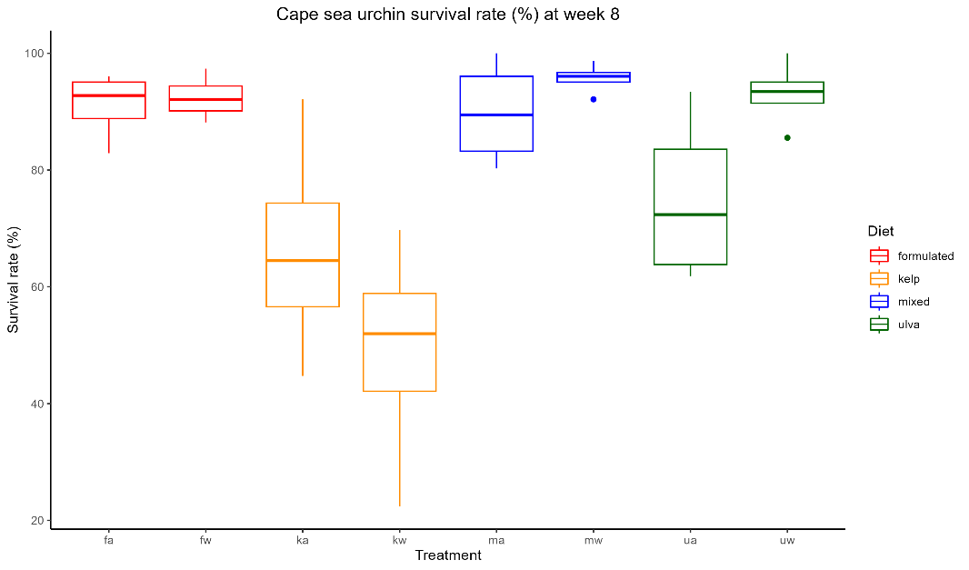

ab

ab

ab

ac

b

bd

c

acd

*Somatic growth*

*SGRdiameter*

The specific growth rate (SGR) (%) of the urchin test diameter (SGRdiam) was not significantly different between treatments for the first two SGR measurement timepoints (SGRdiam (week 4): χ2= 12.614, df = 7, p-value > 0.05, SGRdiam (week 8): F = 0.719, df = 7, p-value > 0.05). In week 13 (F = 4.158, df = 2, p-value < 0.05) and week 18 (F = 4.312, df = 2, p-value <0.05) SGRdiam were significantly impacted by the provision of different dietary treatments. A post hoc Tukey test showed that in week 13, the mixed dietary treatment group, which had the highest SGRdiam (week 13) (mixed ambient: 0.33 ± 0.05%; mixed warm: 0.30 ± 0.04%), and the formulated dietary treatment group, which had the lowest SGRdiam (week 13) (mean ± se) (fa: 0.18 ± 0.05% ; fw: 0.11 ± 0.06%), differed significantly at p < 0.05; the *Ulva* dietary treatment group SGRdiam (week 13) was not significantly different from the other dietary treatment groups. The *Ulva* dietary treatment group had the highest SGRdiam (week 18) (mean ± se) (ambient: 0.04 ± 0.03%; warm: 0.07 ± 0.04%) and differed significantly from the other dietary treatment groups at p<0.05 according to a post hoc Tukey test. The provision of different temperature treatments had a significant impact on SGRdiam (week 23) (F = 8.432, df = 1, p-value < 0.01) with the ambient temperature treatment group (mean ± se) (0.14 ± 0.02%) having a significantly higher SGRdiam (week 23) (t = 2.91, df = 22, p-value < 0.01) than the warm temperature treatment group (mean ± se) (0.05 ± 0.02%).

The mixed diet ambient temperature (ma) treatment group (F = 10.76, df = 4, p-value < 0.001), mixed diet warm temperature (mw) treatment group (F = 12.54, df = 4, p-value < 0.001) and formulated diet ambient temperature (fa) treatment group (χ2= 11.414, df = 4, p-value < 0.05) were the only treatment groups with significant differences in SGRdiam over time. (where were these differences?)

*SGRweight*

The provision of different dietary treatments had a significant impact on the SGR of the wet weight of the whole urchin (SGRweight) (%) (F = 38.23, df = 3, p < 0.001) from the first SGR measurement timepoint, in week 4 (SGRweight (week 4)). A post hoc Tukey test showed that the dietary treatment group with highest SGRweight (week 4)­, the formulated dietary treatment group (mean ± se) (ambient: 0.23 ± 0.03 %; warm: 0.20 ± 0.02 %), and lowest SGRweight (week 4)­, the kelp dietary treatment group (mean ± se) (ambient: -0.03 ± 0.03 %; warm: -0.10 ± 0.04%), were significantly different to one another and to the groups with an intermediate SGRweight (week 4)­, *Ulva* and mixed dietary treatments, at p<0.05. The negative SGRweight (week 4) values for the kelp dietary treatment group indicated that on average the urchins fed kelp had lost weight over the first 4 weeks of the experiment.

Differences in SGRweight between dietary (F = 1.97, df = 3, p-value >0.05) and temperature (F = 2.91, df = 1, p-value >0.05) treatment groups were not significant in week 8.

In week 13, both the dietary (F = 10.45, df = 2, p-value < 0.001) and temperature (F = 25.531, df = 1, p-value < 0.001) factors significantly impacted SGRweight. A post hoc Tukey test showed that the dietary treatment with the highest SGRweight (week 13), the mixed dietary treatment group (mean ± se) (ambient: 0.30 ± 0.03 %; warm: 0.22 ± 0.03 %), and lowest SGRweight (week 13), the formulated dietary treatment group group (mean ± se) (ambient: 0.20 ± 0.01 %; warm: 0.09 ± 0.3 %), were significantly different to one another at p < 0.05; the *Ulva* dietary treatment group SGRweight (week 13) group (mean ± se) (ambient: 0.25 ± 0.03 %; warm: 0.14 ± 0.02 %) was not significantly different from the other dietary treatment groups. All dietary treatment groups had a significantly higher SGRweight (week 13) for their ambient temperature treatment factor than their warm temperature treatment factor (mixed: t = 2.18, df = 6, p-value <0.05; formulated: t = 3.50, df = 6, p-value <0.01; ulva: t = 3.26, df = 6, p-value <0.01). The SGRweight (week 13), averaging across all dietary treatment groups, for the ambient temperature treatment (0.25 ± 0.02%) was significantly higher (t = 3.78, df = 22, p-value < 0.001) than the warm temperature treatment (mean ± se) (0.15 ± 0.02%).

Dietary treatment contributed to significant differences in SGRweight (week 18) (F = 7.057, df = 2, p-value < 0.01). A post hoc Tukey test showed that the dietary treatment group with highest SGRweight (week 18)­, the mixed dietary treatment group (mean ± se) (ma: 0.27 ± 0.05 %; mw: 0.19 ± 0.03 %), and lowest SGRweight (week 18)­, the formulated dietary treatment group (mean ± se) (fa: 0.11 ± 0.07 %; fw: -0.02 ± 0.06 %), were significantly different to one another at p < 0.01; the *Ulva* dietary treatment group SGRweight (week 18) (mean ± se) (ua: 0.17 ± 0.04 %; uw: 15 ± 0.05 %) was not significantly different from the other dietary treatment groups.

Both dietary (F = 12.214, df = 2, p-value <0.001) and temperature (F =6.920, df = 1, p-value < 0.05) treatment factors significantly impacted SGRweight­ (week 23), the final SGR measurement timepoint. A post hoc Tukey test showed that the dietary treatment with the highest SGRweight (week 23), the mixed dietary treatment group (mean ± se) (mixed ambient: 0.13 ± 0.01 %; mixed warm: 0.18 ± 0.02 %), was significantly from the other dietary treatment groups. (continue with 23 – temp is significant in ANOVA but when using t-test to consider temperature difference within each diet there are no significant differences)

(was there a significant increase in SGR over time?).

(generator issues)

At the end of the experiment, after 24 weeks, the final survival rates between the remaining treatments were similar (χ2= 9.95, df = 5, p-value > 0.05).

*GSI*

The provision of different dietary treatments had a significant effect on gonadal somatic index (GSI) of the urchins (GSI9: χ2= 31.198, df = 3, p-value < 0.001, GSI19: F = 48.397, df = 2, p-value < 0.001; GSI26: F = 125.708, df = 2, p-value < 0.001). The temperature treatment factor did not have a significant impact on the gonadal somatic index (GSI) (%) (GSI9: χ2= 0.132, df = 1, p-value > 0.05; GSI19: F = 0.516, df = 1, p-value > 0.05; GSI26: F = 0.474, df = 1, p-value > 0.05). After 26 weeks, an interaction was present for the temperature and dietary treatments effect on GSI (F = 4.917, df = 2, p < 0.05).

After 9 weeks, urchins fed the kelp and *Ulva* dietary treatments had significantly lower GSI’s than the formulated dietary treatment. Thereafter, all dietary treatments had significantly different GSI’s.

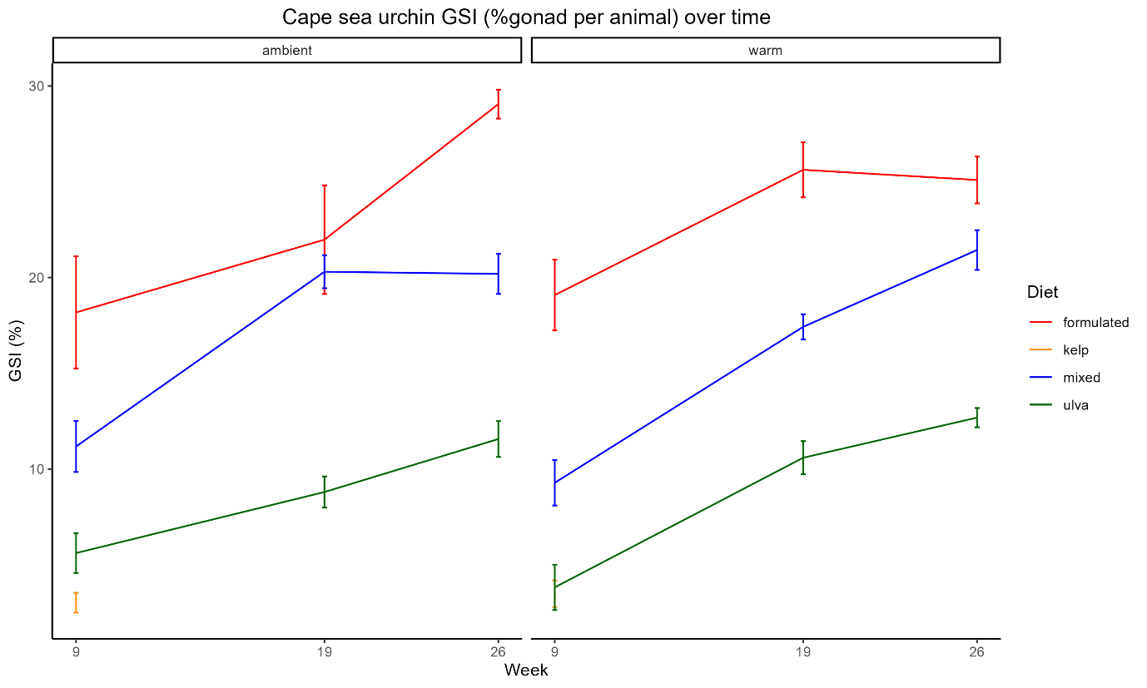

a

ab

bc

c

Supplementary figures

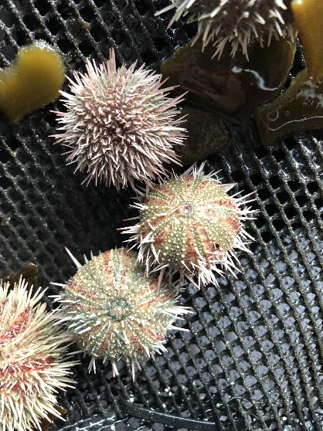

Figure 2: An example of the level of spine loss severity which resulted in the removal of the urchin from the tank and recorded as a morbidity.

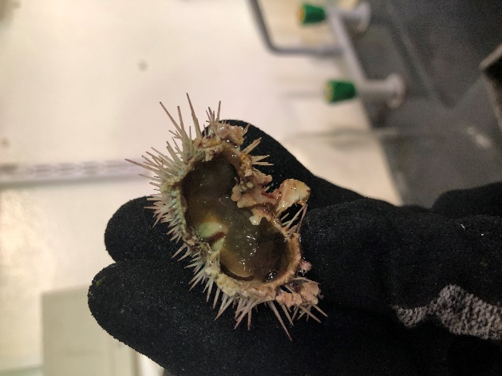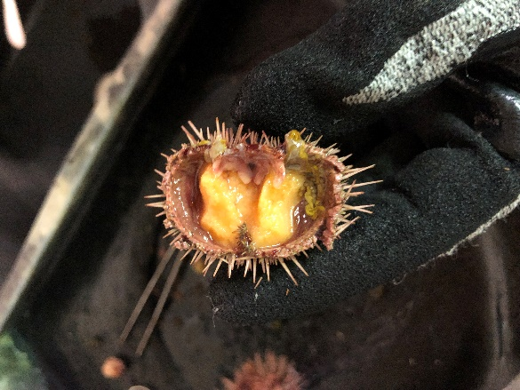

Kelp diet

Formulated diet



*Ulva* diet

Figure : GSI images at week 9